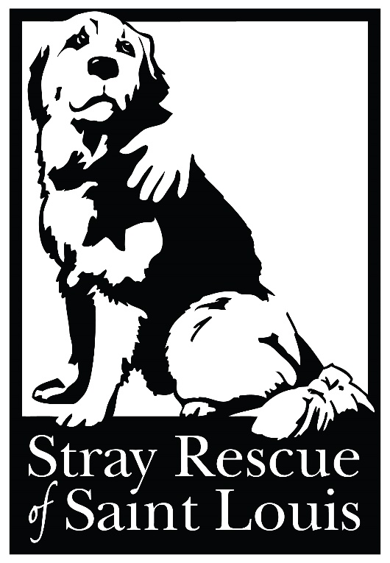

Proud Sponsors of

**STRAY**

**RESCUE**

SSS

Enter for a chance to win a

one-of-a-kind Fourteen-karat yellow gold amethyst, citrine and diamond necklace

worth $6,000.00

A brown and white dog

Description generated with very high confidence

HELP SUPPORT THIS

GREAT ORGANIZATION

Raffle tickets are

$10 each

Drawing December 20th!!!